CA-C20L:INTERNET TECHNOLOGIES LAB

1.Demonstrate EMail working (Sending Receiving, forward)
Sending an Email

1. Compose the Email:
Open your email client (e.g., Gmail, Outlook).
Click on "Compose" to create a new email.
Fill in the recipient's email address in the "To" field.
Add a subject and write your message in the body.

2. Sending the Email:
Click the "Send" button.
The email is sent to the Simple Mail Transfer Protocol (SMTP) server of your email provider.
The SMTP server processes the email and forwards it to the recipient's email server.

Receiving an Email

1. Email Delivery:
The recipient's email server receives the email.
The email is stored in the recipient's mailbox on their email server.

2. Checking Email:
The recipient opens their email client and clicks "Refresh" or "Check Mail."
The email client connects to the recipient's email server using protocols like Post Office Protocol (POP3) or Internet Message Access Protocol (IMAP).
The email is downloaded (POP3) or synchronized (IMAP) to the recipient's device.

Forwarding an Email

1. Select the Email:
Open the received email you want to forward.

2. Forward the Email:
Click on the "Forward" button.
Enter the new recipient's email address in the "To" field.
Add any additional message if needed.
Click "Send" to forward the email.

Conclusion
Sending an Email: Compose, add recipient, subject, and message, then send.
Receiving an Email: Email server receives, store in mailbox, check email client to view.
Forwarding an Email: Select received email, click forward, add new recipient, and send.

2. How to create, organize meeting in Zoom/ Google Meet
Creating and Organizing a Meeting in Zoom
1. Creating a Meeting
1. Sign In:
Open the Zoom app or go to [zoom.us](https://zoom.us) and sign in to your account.

2. Schedule a Meeting:
Click on "Schedule" (in the app) or "Schedule a Meeting" (on the website).
Fill in the meeting details:
Topic: Enter the meeting name.
Description: (Optional) Add a description.
When: Set the date and time.
Duration: Set the meeting duration.
Time Zone: Choose your time zone.
Recurring Meeting: Check if the meeting repeats.
Meeting ID: Choose "Generate Automatically" for security.
Passcode: Set a passcode for security (recommended).
Waiting Room: Enable if you want to control who joins.
Video: Choose if the host and participants' video will be on/off.
Audio: Choose "Telephone and Computer Audio."

3. Save and Invite:
Click "Save."
After saving, you can copy the invitation link or send it directly via email.

2. Starting a Meeting
1. Start the Scheduled Meeting:
Open the Zoom app or website.
Go to "Meetings" and find your scheduled meeting.
Click "Start" next to the meeting.

2. Admit Participants:
If the Waiting Room is enabled, admit participants as they join.

3. During the Meeting
1. Manage Participants:
Use the "Participants" button to see and manage attendees.
Mute/unmute participants, assign cohosts, or remove participants if needed.

2. Share Screen:
Click "Share Screen" to present your screen.
Choose the specific window or application to share.

3. Record Meeting:
Click "Record" to start recording the meeting.

Creating and Organizing a Meeting in Google Meet

1. Creating a Meeting
1. Sign In:
Go to [Google Meet](https://meet.google.com) and sign in with your Google account.

2. Schedule a Meeting:
Click "New Meeting."
Choose "Schedule in Google Calendar."
Fill in the meeting details:
Title: Enter the meeting name.
Date and Time: Set the date and time.
Guests: Add participants' email addresses.

3. Save and Send Invitations:
Click "Save."
Google Calendar will prompt you to send email invitations to the guests. Click "Send."

2. Starting a Meeting
1. Start from Google Calendar:
Open Google Calendar.
Find your scheduled meeting and click on it.
Click the "Join with Google Meet" link.

2. Admit Participants:
Participants can join the meeting using the link from the invitation.
Admit participants as they request to join.

3. During the Meeting
1. Manage Participants:
Use the "People" button to see and manage attendees.
Mute/unmute participants, pin participants, or remove participants if needed.

2. Share Screen:
Click "Present Now" to share your screen.
Choose "Your entire screen," "A window," or "A tab."

3. Record Meeting:
Click the threedot menu (More options) and select "Record meeting."
Conclusion
Creating a Meeting in Zoom: Sign in, schedule a meeting, fill in details, save, and invite.
Starting a Meeting in Zoom: Start from the app/website, admit participants, manage during the meeting.
Creating a Meeting in Google Meet: Sign in, schedule via Google Calendar, fill in details, save, and send invitations.
Starting a Meeting in Google Meet: Start from Google Calendar, join the meeting, admit participants, manage during the meeting.

3. Create a form by using various attributes of the input tags (text box, multiline textbox, option button, check box)

Program:
<html>
<head>
<title> Complete Form</title>
</head>
<body bgcolor="blue" text="red">
<h1><center>Registration Form</center></h1>
<form action=" ">
<p>
<label>Enter your email id:
<input type = "text" name = "myname" size = "24" maxlength = "25" />
</label>
</p>
<p>
<label>Enter the password:
<input type = "password" name = "mypassword" size = "20" maxlength = "20" />
</label>
</p>
<p>Sex</p>
<p>
<label><input type="radio" name="act" value="one"/>Male</label>
<label><input type="radio" name="act" value="two"/>Female</label>
</p>
<p>Which of the following Accounts do you have?</p>
<p>
<label><input type="checkbox" name="act" value="one"/>Gmail</label>
<label><input type="checkbox" name="act" value="two"/>Facebook</label>
<label><input type="checkbox" name="act" value="three"/>Twitter</label>
<label><input type="checkbox" name="act" value="four"/>Instagram</label>
</p>
<p> Any Suggestions?</p>
<p>
<textarea name="feedback" rows="5" cols="100">
</textarea>
</p>
<p>Click on Submit if you want to register</p>
<p>
<input type="SUBMIT" value="SUBMIT"/>
<input type="RESET" value="RESET"/>
</p>
</form>
</body>
</html>
Output:

4. Create a simple HTML page by using some of the basic tags (hyperlink, marquee, image)
<html>
<head> <title> ISBR BCA DEPARTMENT </title></head>
<body bgcolor="gray" text="red">
<h1><center> ISBR UG COLLEGE </center></h1>
<img src="isbr.png" align = "left" height="300" width="300" >
<hr>
<h1 style="color:blue;text-align:center;"> BCA in ISBR:</h1>
<p>
<h3 style="color:violet;text-align:center;">Bachelor of Computer Application (BCA) </h3><br>
With the rapid growth of IT industry in India, industry has created a lot of opportunities for computer graduates. <br>Through labs, lectures and projects, you will also <br>
1.Study programming methodology to design data structures<br>
2.Receive in-depth instruction in practical subjects<br>
3.Learn the principles of programming languages<br>
</p>
<p> For Admissions,<a href=https://www.isbr.in/bca.html> Click Here </a>
</p>
<h3><marquee > ISBR – BCA DEPARTMENT </h3></marquee>
</body>
</html>
OUTPUT
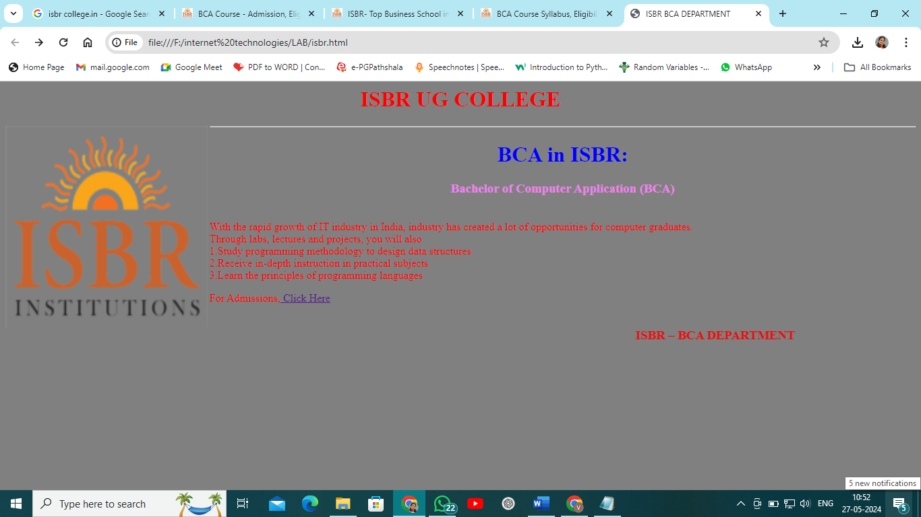

5. Create a web page with multiple types of style sheet used in a single page
<html>
<head>
<link rel="stylesheet" type="text/css" href="myex.css">
<style>
body
{
background-color: gray;
}
p
{
color:red;
text-align:center;
}
</style>
<body>
<h1 style="color:blue;text-align:center;">This text is an example for inline CSS</h1>
<b><p> Internal Style sheet is applied in this text</p></b>
<h2>The External style sheet is applied on this heading</h1>
</body>
</html>
CSS External file: myex.css
h2
{
color: navy;
margin-left: 20px;
}

Output:

6. Write a CGI sample program to send output back to the user

Step1: Install strawberry perl to the system
Step 2: create the code and save the program with .pl exntension
Step 3: goto command prompt of perl and execute the perl program successfully.
Step4. Install Apache or Xamp web server to the system.
Stept 5 : run the program in webserver local host

CGI Code :

#!"C:\Strawberry\perl\bin\perl.exe"
print "Content-type:text/html\n\n";
use CGI':standard';
print "<html><body>";
$p=param("p");
@greetings=("Hi user,Good morning","Welcome!");
$i=int rand scalar @greetings;
print "Hi $p, $greetings[$i]";

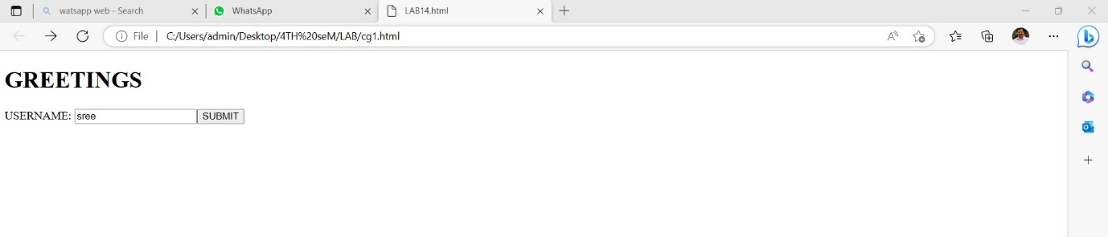

7. Create Time-Table using table tag
Program:
<html>
<head>
<title>IV SEM BCA - TIMETABLE</title>
</head>
<body bgcolor="gray" text=”red”>
<font face="times new roman" size="4">
<h1 align="center">ISBR COLLEGE</h1>
<h2 align="center">Dept. of Computer Applications</h2>
<hr/>
<h3 align="center">IV SEM BCA</h3>
<hr/>
<table align="center" border="3" cellpadding="3">
<tr>
<th>DAY/TIME</th>
<th>9.00-9.50</th>
<th>9.50-10.40</th>
<th>10.40-10.50</th>
<th>10.50-11.40</th>
<th>11.40-12.30</th>
</tr>
<tr align="center">
<td>MONDAY</td>
<td>IT</td>
<td>SE</td>
<td rowspan="6" align="center" valign="center">BREAK</td>
<td>ENG</td>
<td>LANG</td>
</tr>
<tr align="center">
<td>TUESDAY</td>
<td>ENG</td>
<td>ADA</td>
<td>SE</td>
<td>IT</td>
</tr>
<tr align="center">
<td>WEDNESDAY</td>
<td colspan="2" bgcolor="yellow">IT/ADA LAB</td>
<td>SE</td>
<td>ADA</td>
</tr>
<tr align="center">
<td>THURSDAY</td>
<td>IT</td>
<td>ADA</td>
<td>LANG</td>
<td>SE</td>
</tr>
<tr align="center">
<td>FRIDAY</td>
<td>ADA</td>
<td>SE</td>
<td>IT</td>
<td>ENG</td>
</tr>
</font>
</table>
</body>
</html>
Output:
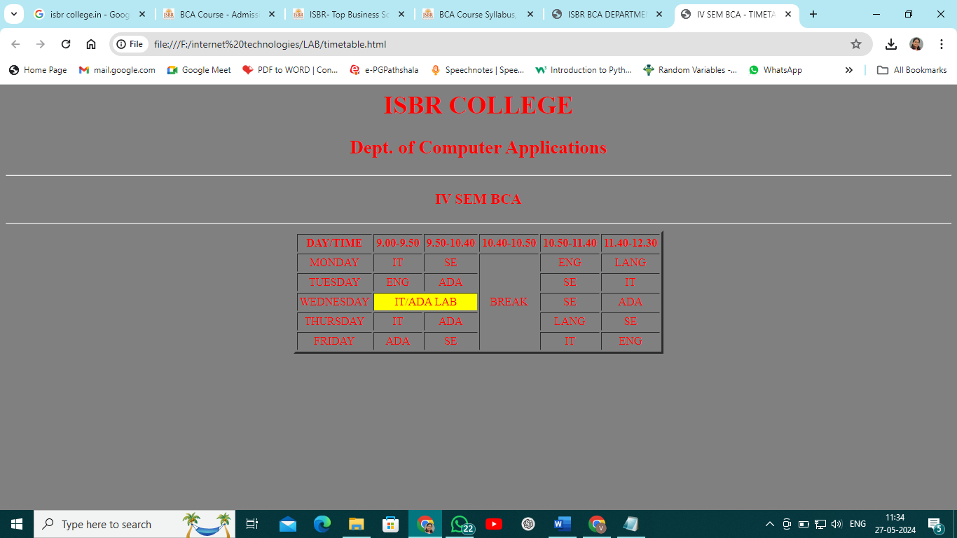
8. Creation of Frames in browser window using HTML
Program:
<html>
<head> <title>Frameset Demo</title>
</head>
<frameset rows="30%,40%,30%">
<frame src="a1.html">
<frame src="a2.html">
<frame src="a3.html">
</frameset>
</html>
Output:
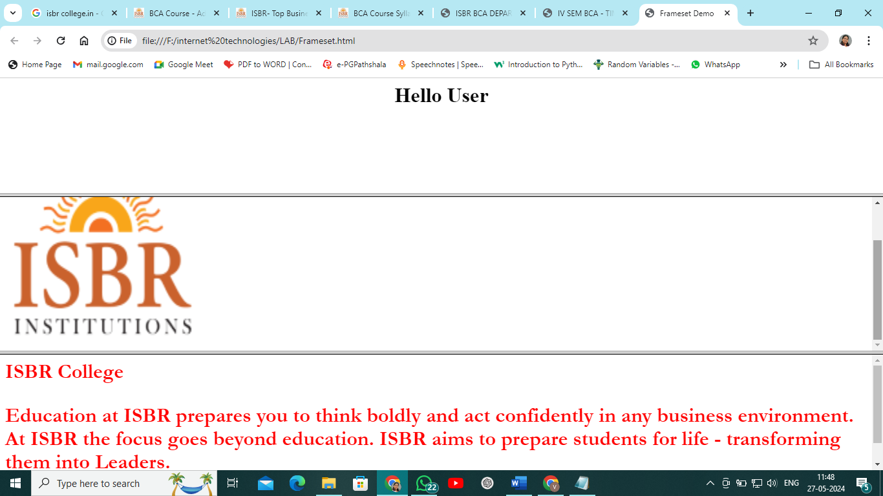
Code for a1.html:
<html>
<head><title> hello</title></head>
<body>
<h1><center>Hello User</center></h1>
</body>
</html>

Code for a2.html:
<html>
<head><title>College Logo </title></head>
<body>
<img src="isbr.png" height="300" width="300" >
</body>
</html>

Code for a3.html:

<html>
<head>
<title>College Details</title>
</head>
<body>
<h1>
<font face="Garamond" color="Red">
ISBR College
<p> Education at ISBR prepares you to think boldly and act confidently in any business environment. At ISBR the focus goes beyond education. ISBR aims to prepare students for life - transforming them into Leaders. </p>
</font>
</h1>
</body>
</html>

9. Write a java script program to create dialogue boxes using alert, confirm and prompt
<?xml version="1.0"?>
<!doctype html Public "-//w3c//dtd xhtml 1.0 transitional//en"
"http://www.w3.org/tr/xhtml1/dtd/xhtml1-transitional.dtd">
<html xmlns="http://www.w3.org/1999/xhtml">
<head>
<title> SUM OF N NUMBERS</title>
<script type="text/javascript">
function sum()
{
var n,s,response;
n=prompt("Enter a positive integer");
n=parseInt(n);
s=0;
for(var i=1;i<=n;i++)
s=s+i;
alert("Sum of numbers upto " + n + " is : "+s);

response=confirm("happy with the output??");
if(resposnse==true)
{
alert("happy");
return true;
}
else
{
alert("not happy");
return false;
}
}
</script>
</head>
<body>
<h1 align="center">SUM OF N NUMBERS</h1>
<form>
<input type="button" value="Calculate Sum" onclick="sum();" />
</form>
</body>
</html>
output:
prompt box:
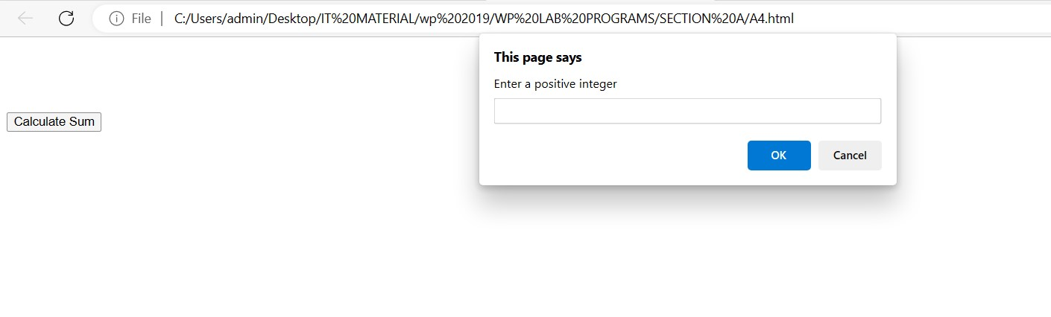
Alert box:
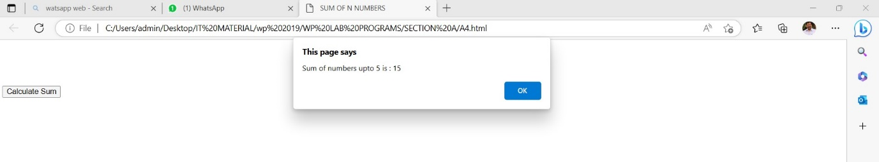

Confirm box:
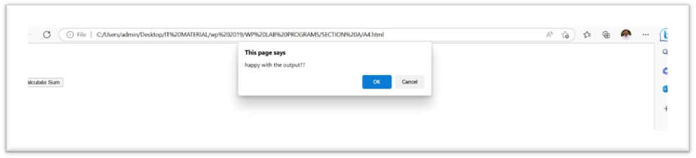
10. Write a java script program on Form Validations
<!DOCTYPE html>
<html>
<head>
<title>Email Validation</title>
<script>
function validateEmail() {
var email = document.forms["emailForm"]["email"].value;
var emailPattern = /^[^\s@]+@[^\s@]+\.[^\s@]+$/;

if (!emailPattern.test(email)) {
alert("Invalid email format");
return false;
}

alert("Email is valid");
return true;
}
</script>
</head>
<body>
<h2>Email Validation Example</h2>
<form name="emailForm" onsubmit="return validateEmail()">
<label for="email">Email:</label>
<input type="text" id="email" name="email"><br><br>
<input type="submit" value="Submit">
</form>
</body>
</html>
OUTPUT:
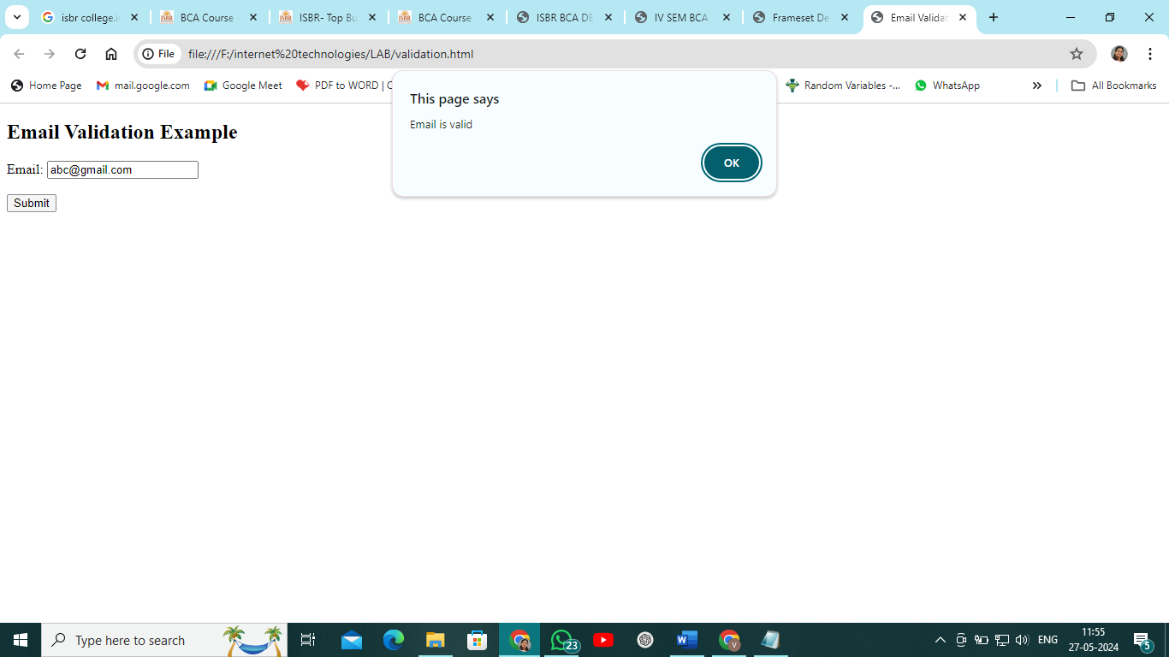
11. Write a java script program to perform four arithmetic operations: Addition, Subtraction, Multiplication and Division on two numbers
<html>
<body>
<script>
var n1, n2, res;
n1=prompt("enter n1 value");
n1=parseInt(n1);
n2=prompt("enter n2 value");
n2=parseInt(n2);
res = n1+n2;
document.write("Add = " + res + "<br/>");
res = n1-n2;
document.write("Subtract = " + res + "<br/>");
res = n1*n2;
document.write("Multiply = " + res + "<br/>");
res = n1/n2;
document.write("Divide = " + res + "<br/>");
</script>
</body>
</html>
Output:
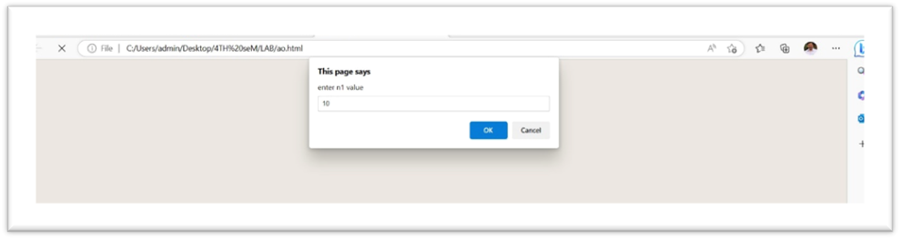

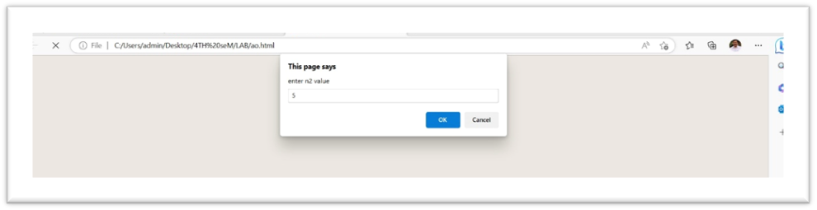
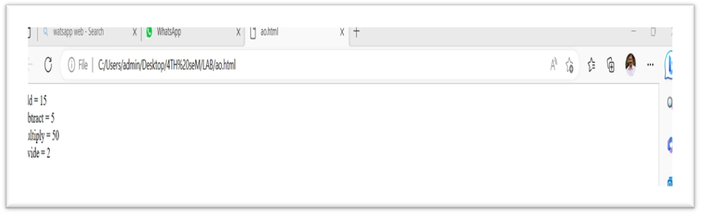
12. Create a web site of our College
<html>
<head><title> ISBR College</title></head>
<body bgcolor="gray" text= "blue">
<h1> <center>ISBR COLLEGE</center></h1>
<h2> <center>ELECTRONIC CITY</center></h2>
<center>BENGALURU</center>
<img src="isbr.png" width="300" height="300" align="right">
<h1>
COURSES OFFERED
</h1>
<ol>
<li><b> UG COURSES</b>
<b><ol>SCIENCE</b>
<li> BCA </li>
</ol>
<b><ol>COMMERCE</b>
<li> BCOM </li>
<li> BBA </li>
<li>BBA AVIATION</li>
</ol>
<li><b>PG COURSES</b>
<ol><li>MBA</li>
<li> MCA </li>
<li> MCom</li></ol>
</ol>
</body>
</html>
Output:
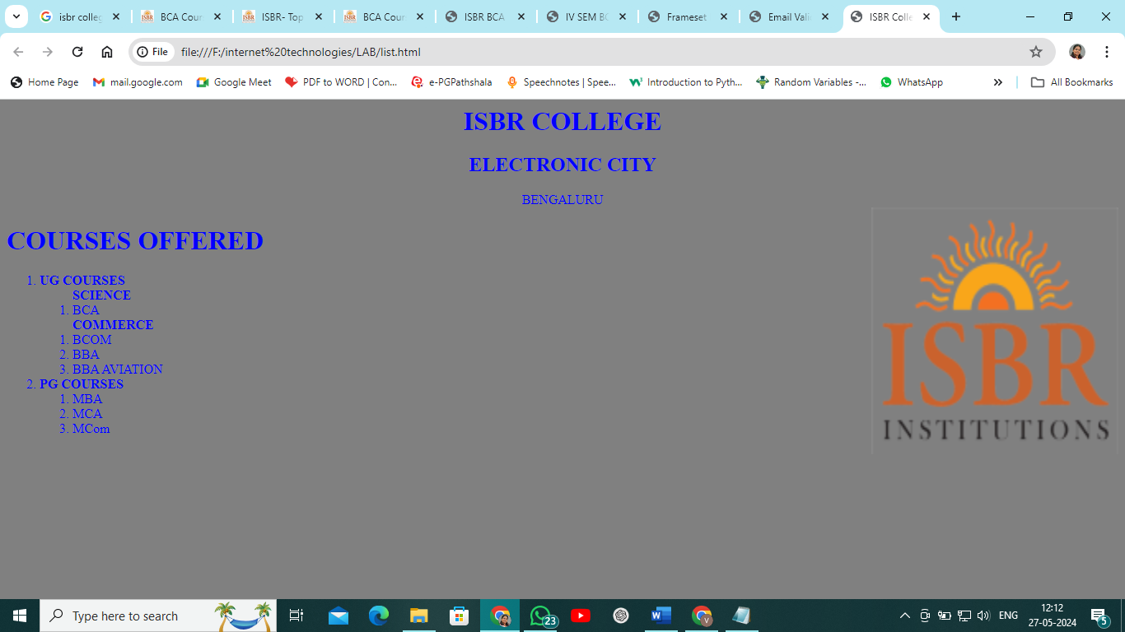

var email = document.forms["emailForm"]["email"].value;
- document.forms["emailForm"]["email"].value accesses the value of an input field named email within a form named emailForm.
- The document.forms collection allows you to access forms in the document by their name attribute.
var emailPattern = /^[^\s@]+@[^\s@]+\.[^\s@]+$/;
- emailPattern is a regular expression (regex) that defines the format for a valid email address.
- ^[^\s@]+@[^\s@]+\.[^\s@]+$ breakdown:
  - ^: Asserts the position at the start of the string.
  - [^\s@]+: Matches one or more characters that are not whitespace (\s) or @.
  - @: Matches the @ symbol.
  - [^\s@]+: Matches one or more characters that are not whitespace (\s) or @.
  - \.: Matches a literal dot ..
  - [^\s@]+: Matches one or more characters that are not whitespace (\s) or @.
  - $: Asserts the position at the end of the string.
if (!emailPattern.test(email)) {
alert("Invalid email format");
return false;
}
- emailPattern.test(email) tests whether the email value matches the regex pattern.
- If the email does not match the pattern (!emailPattern.test(email)), an alert box with the message "Invalid email format" is displayed.
- return false; stops the form submission process (assuming this function is called on form submission).

